**Farmer Argo-Based Management System Course: UE22CS351A**

**:  Database Management System**

**FINAL REPORT**

**Semester: 5**

**Section: L**

**Team Members:**

**1. Suhas PH (PES2UG22CS588) 2. Chandan N(PES2UG22CS140)**

# 1. Introduction

## 1.1 Purpose

This Software Requirements Specification (SRS) document outlines the essential features, functionality, and performance requirements for the Farmer Agro-Based Management System. This system is designed to connect farmers and buyers through a web-based platform where farmers can manage their product listings and buyers can place orders for agricultural goods. The primary goal is to streamline the agricultural sales process, providing an efficient, secure, and user-friendly experience for both parties.

## 1.2 Scope

The Farmer Agro-Based Management System is intended for use by farmers who wish to sell their agricultural products and buyers looking to purchase these products. The system allows farmers to manage their product inventory, while buyers can browse, order, and track their purchases. The system is built to ensure secure transactions, reliable performance, and ease of use across various devices.

## 1.3 Definitions, Acronyms, and Abbreviations

* **Farmer**: A registered user who lists and manages agricultural products for sale.
* **Buyer**: A registered user who purchases products listed by farmers.
* **UI**: User Interface.
* **DB**: Database.

**1.4 References**

* IEEE Standard for Software Requirements Specifications (IEEE Std 830-1998).

## 1.5 Overview

This document is structured to provide a clear understanding of the system’s requirements, including functional and non-functional aspects, user interfaces, and external interfaces. The intention is to serve as a comprehensive guide for developers, testers, and stakeholders involved in the project.

# 2. Overall Description

## 2.1 Product Perspective

The Farmer Agro-Based Management System is a web-based application that interfaces with a centralized database. It serves as an independent platform allowing farmers to manage their product offerings and buyers to make purchases directly through the system. The application is designed to ensure secure data handling, intuitive navigation, and compatibility with various devices.

## 2.2 Product Functions

The system is built around key functionalities that include:

* **User Registration and Authentication**: Users can securely register and log in to the system.
* **Product Management**: Farmers can add, update, and remove product listings.
* **Order Placement**: Buyers can browse products, place orders, and track their purchases.
* **Order Management**: Farmers can view and manage orders placed by buyers.
* **Sales Tracking**: Farmers can monitor their sales and view detailed reports.
* **Account Management**: Users can manage their personal information and view order histories.

## 2.3 User Classes and Characteristics

The primary users of this system are:

* **Farmers**: Individuals who manage product listings and fulfill orders.
* **Buyers**: Individuals who browse products and place orders.
* **Administrators**: Users who maintain the database and oversee system operations.

## 2.4 Operating Environment

* **Software**: The system is a web-based application, accessible through standard web browsers (e.g., Chrome, Firefox).
* **Hardware**: Users access the system via desktops, laptops, tablets, or smartphones with an internet connection.

## 2.5 Design and Implementation Constraints

* The system must provide secure data transmission to protect user information and transaction details.
* Compliance with relevant agricultural regulations is required for product listings.

The user interface must be responsive and accessible across various devices to ensure a consistent user experience.

## 2.6 Assumptions and Dependencies

* The system assumes that users have access to devices with internet connectivity and a

modern web browser.

* A stable network connection is necessary for accessing the database and conducting transactions.

# 3. External Interface Requirements

## 3.1 User Interfaces

The system includes the following interfaces:

* **Web Interface**: The primary interface through which users interact with the system. It includes functionalities for login, registration, product management, order placement, and sales tracking.
* **Admin Interface**: Used by administrators to manage system operations, including database maintenance and user management.

## 3.2 Hardware Interfaces

* **Client Devices**: The system is accessible on any device with internet access, such as desktops, laptops, tablets, or smartphones.
* **Server**: The database and web application are hosted on a server that ensures data security and reliability.

## 3.3 Software Interfaces

* **Database Interface**: A MySQL database is used to store user data, product information, and transaction records.
* **API**: Potential integration with external services (e.g., payment gateways) for enhanced functionality.

## 3.4 Communication Interfaces

• **HTTPS**: Secure communication between the client and server is ensured through HTTPS, protecting data during transmission.

# 4. System Features

## 4.1 User Registration and Authentication

**Description**: The system provides a secure process for users to register and authenticate. **Functional Requirements**:

• Users must be able to register by providing an email, phone number, and password.

The system must authenticate users upon login, ensuring the correct credentials are provided.

## 4.2 Product Management

**Description**: Farmers can manage their product listings directly through the system. **Functional Requirements**:

* The system must allow farmers to add new products, including details such as product name, description, and price.
* Farmers must be able to edit or remove their product listings as needed.

## 4.3 Order Placement and Management

**Description**: Buyers can place orders for products listed by farmers, and farmers can manage these orders.

**Functional Requirements**:

* Buyers must be able to select products, specify quantities, and place orders.
* The system must track order status and allow farmers to confirm or update orders.

## 4.4 Sales Tracking

**Description**: Farmers can track their sales within the system, providing insights into their business performance.

**Functional Requirements**:

* The system must calculate and display total sales for each farmer.
* A summary of sales data should be available for farmers to review.

## 4.5 Account Management

**Description**: Users can manage their account details and view their transaction history. **Functional Requirements**:

* The system must allow users to update their profile information, including name and contact details.
* Users must be able to view their past orders and, for farmers, their sales records.

# 5. Non-Functional Requirements

## 5.1 Performance Requirements

* The system should respond to user inputs within a maximum of 3 seconds under normal conditions.
* Order processing and confirmation should be completed within 5 seconds.

## 5.2 Security Requirements

• All sensitive data, such as user passwords, must be encrypted both in storage and during transmission.

The system must implement secure login procedures to prevent unauthorized access.

## 5.3 Usability Requirements

* The user interface should be intuitive and straightforward, allowing users to navigate the system with ease.
* The system should be compatible with a wide range of devices, ensuring accessibility for all users.

## 5.4 Reliability Requirements

* The system must maintain an uptime of at least 99.9% to ensure availability for users.
* Data integrity must be maintained during all transactions and database updates.

# 6. Other Requirements

## 6.1 Regulatory Requirements

• The system must adhere to all applicable agricultural and trade regulations, particularly those related to product listings and sales.

## 6.2 Environmental Requirements

• The system should operate effectively within typical indoor environmental conditions, with no special hardware requirements.

ER DIAGRAM:

Its uploaded as separate png file

Relation Schema:

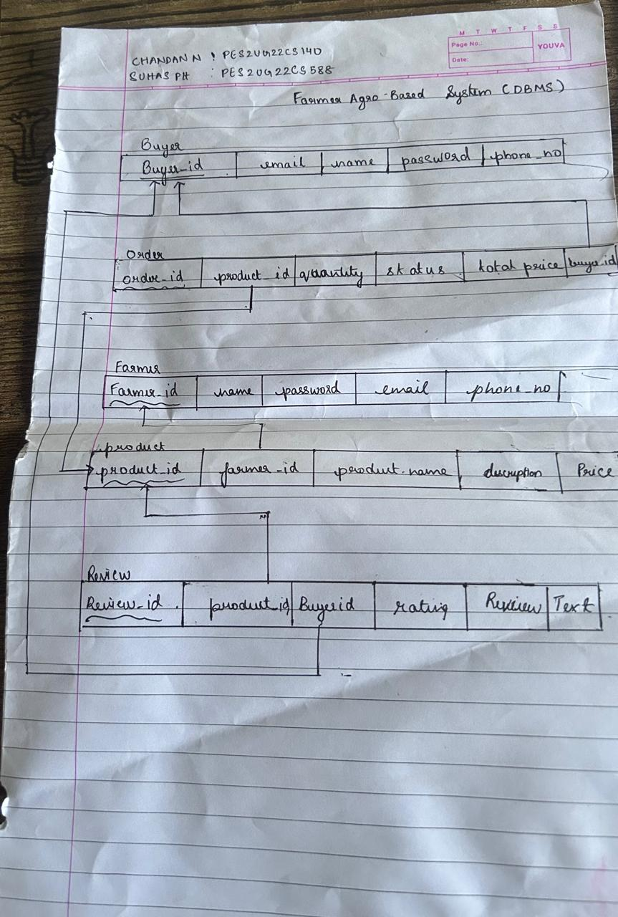

DDL COMMANDS

1. BUYERS TABLE

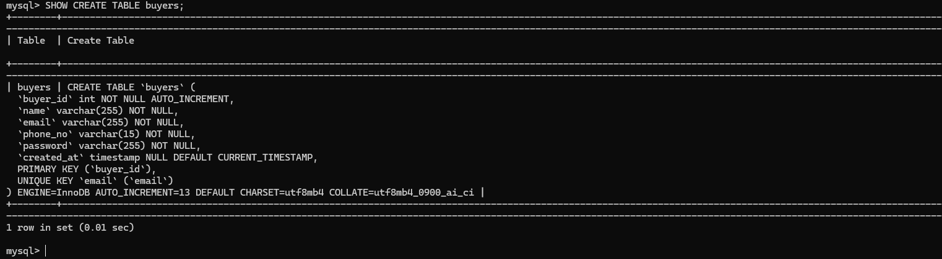

2)FARMERS TABLE

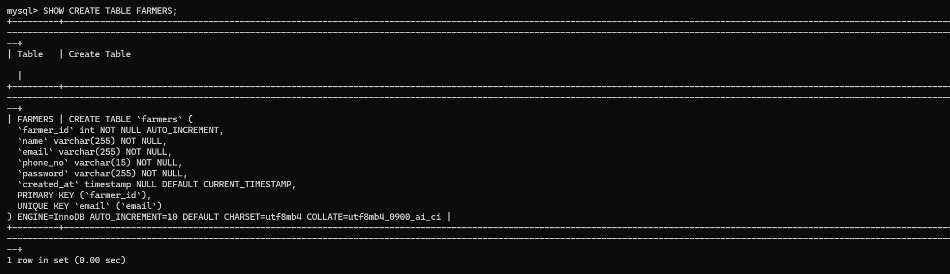

3)Products Table

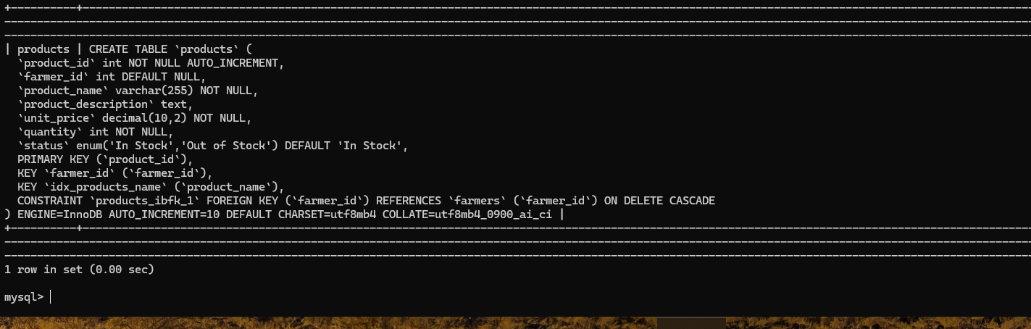

4) ORDERS TABLE

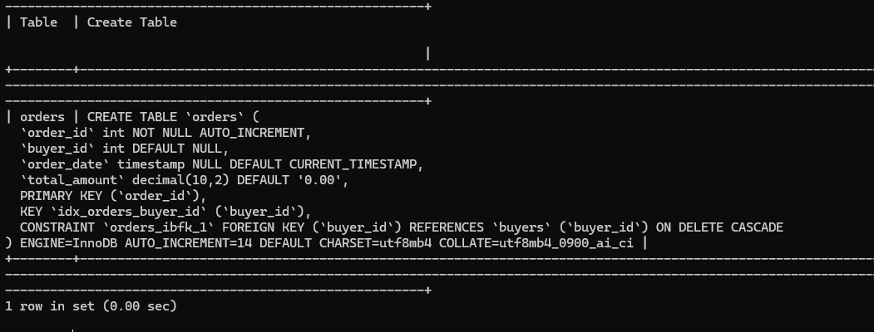

5) ORDER_ITEMS TABLE

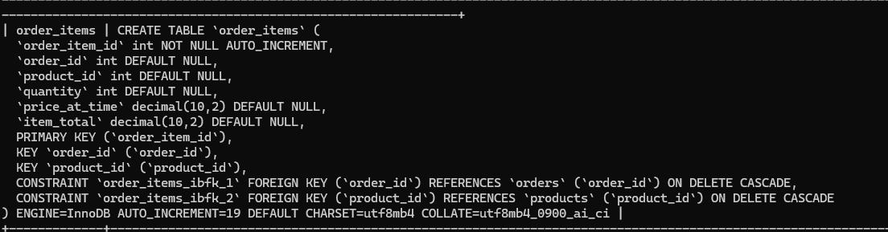

6) REVIEWS TABLE

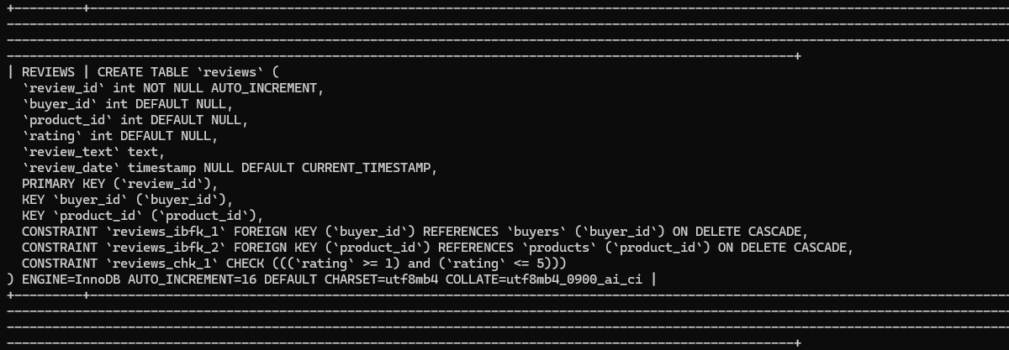

QUERIES ACORDING TO RUBRICS(Nested, Aggregated , Join) ;

1)

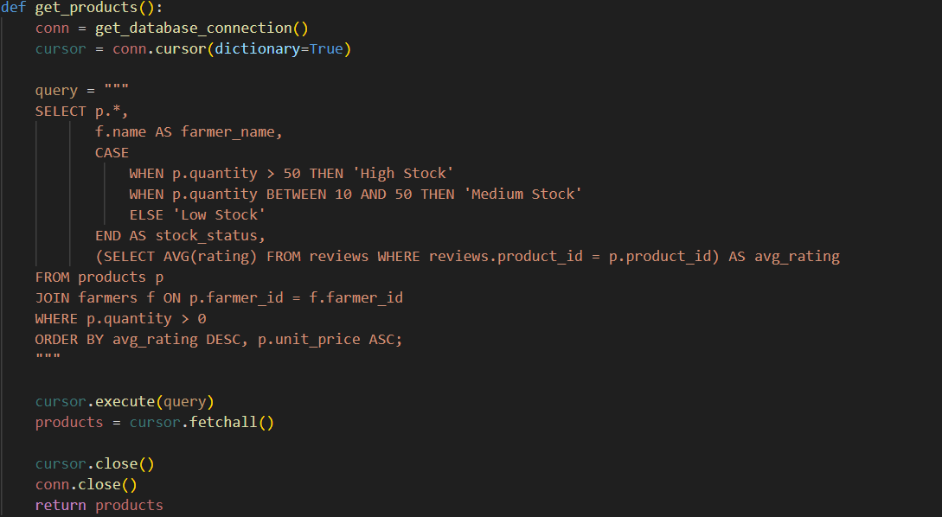

2)

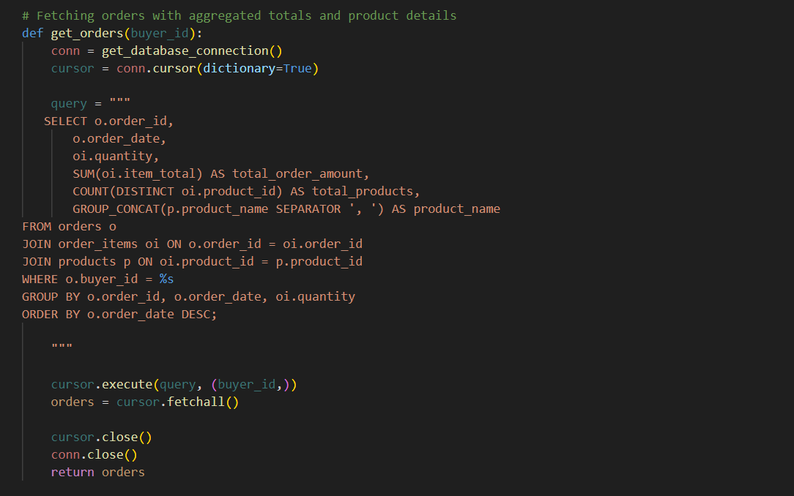

3)

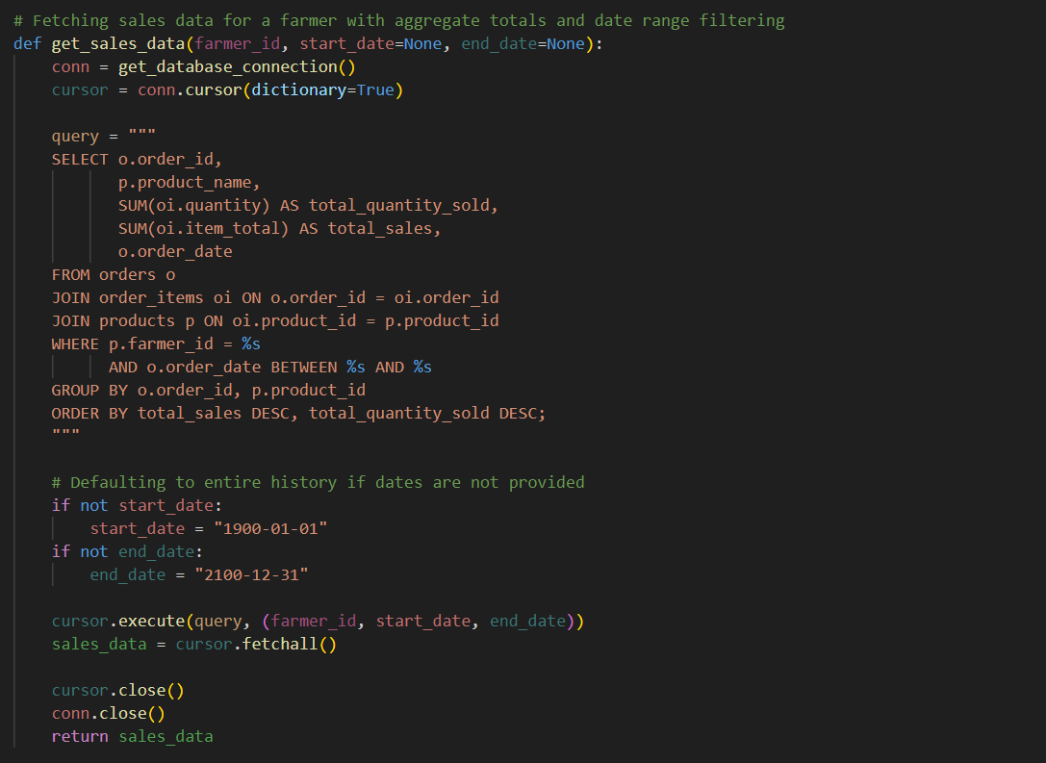

4)

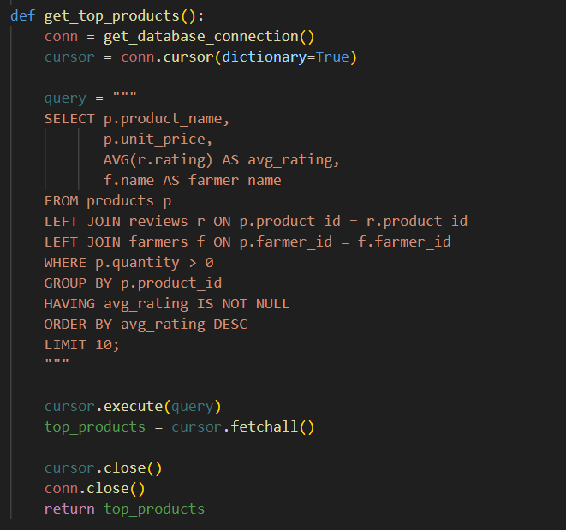

5)

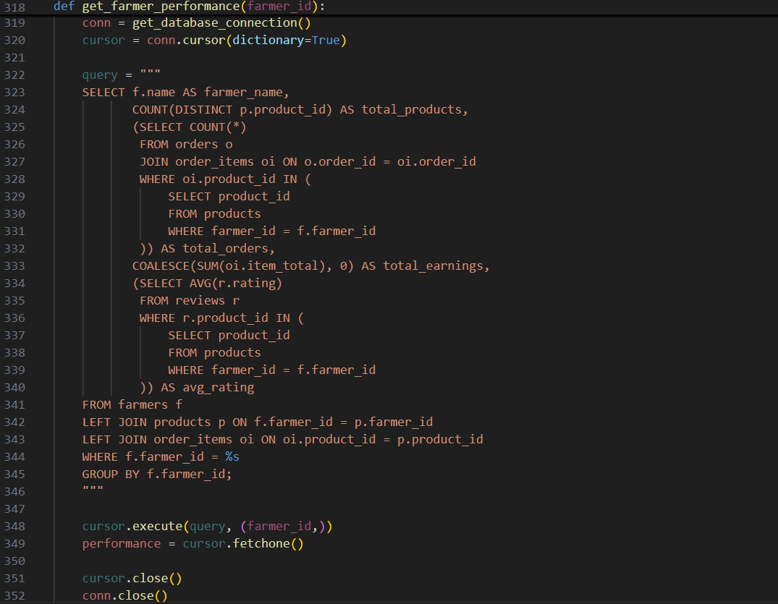

UI

1)Register((Similar for Farmer)

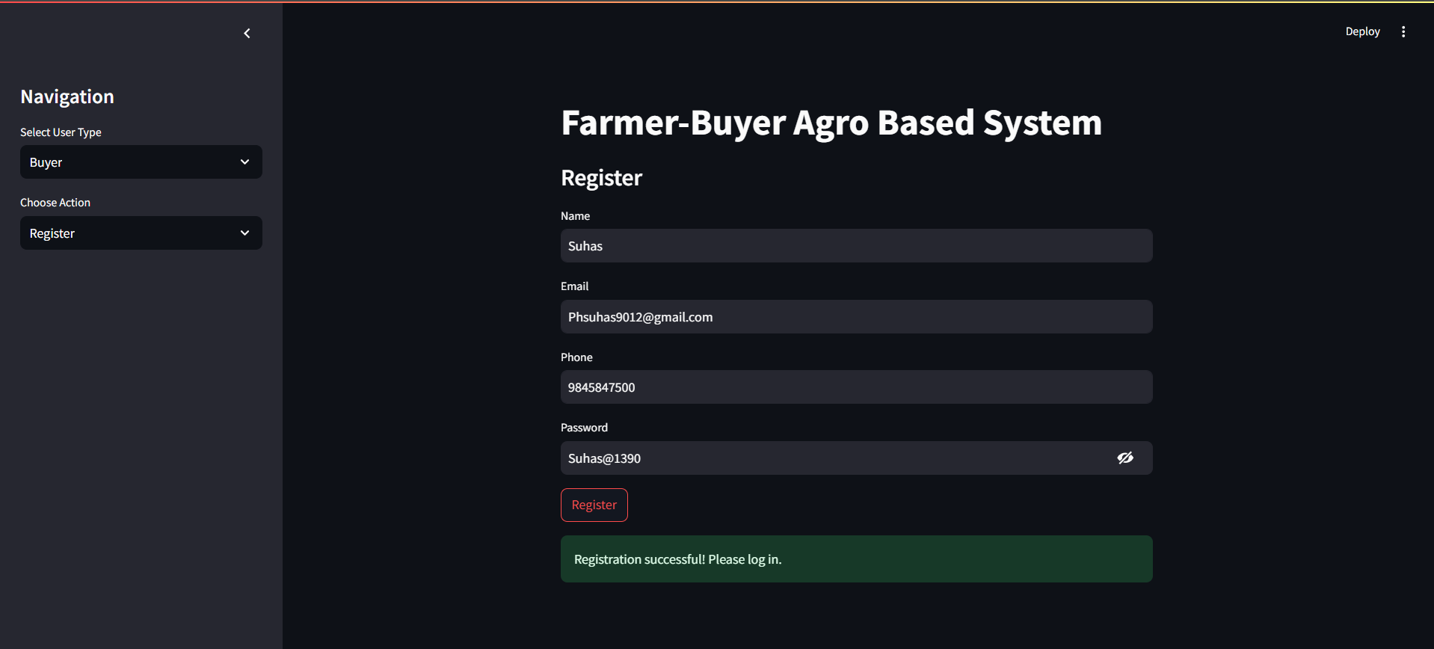

2)Login(Similar for Farmer)

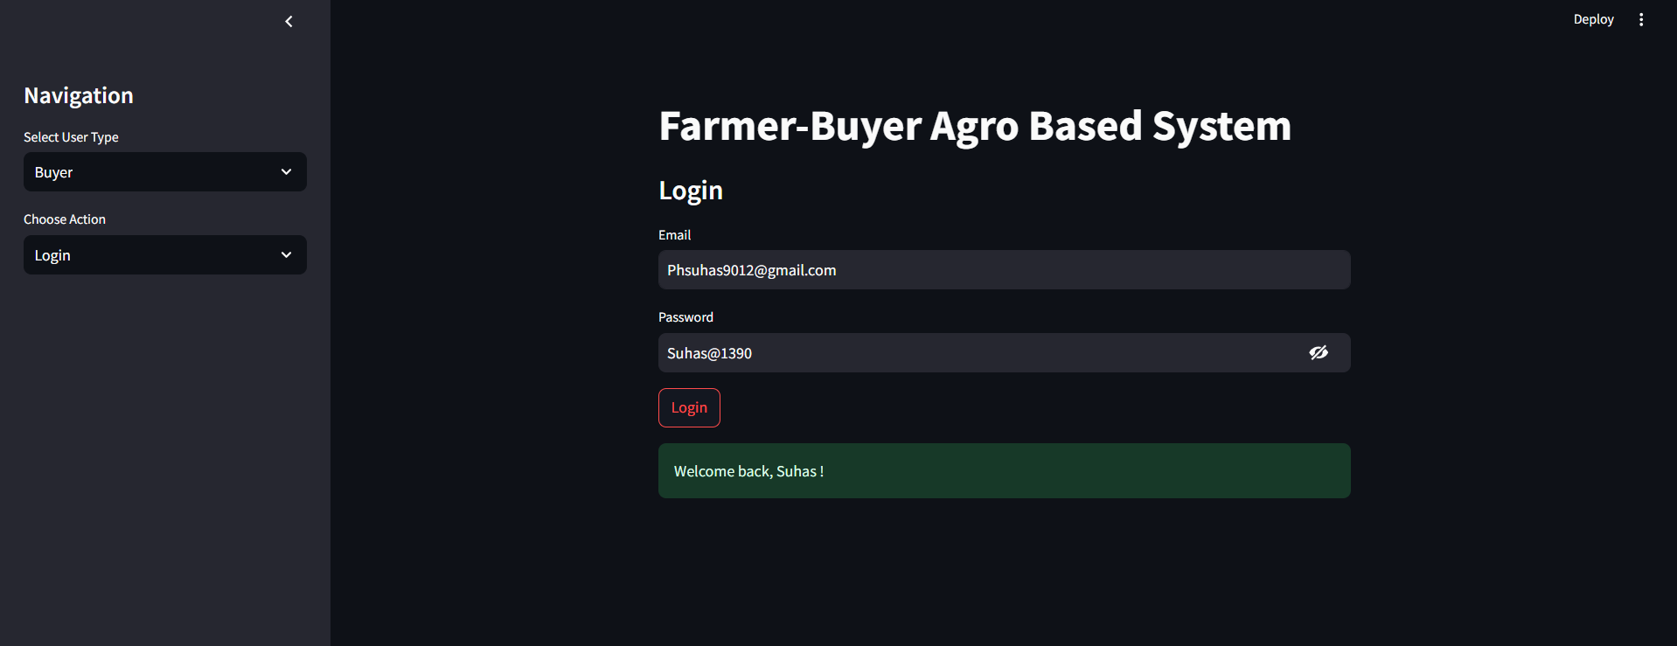

3)Browse Products(for Buyers)

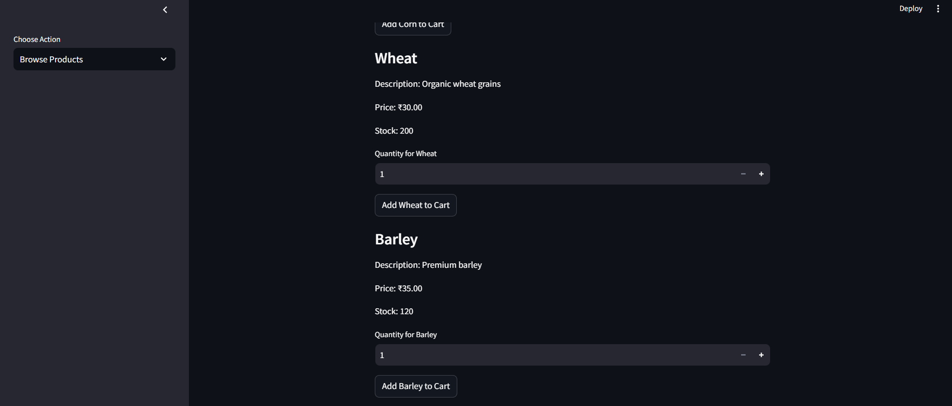

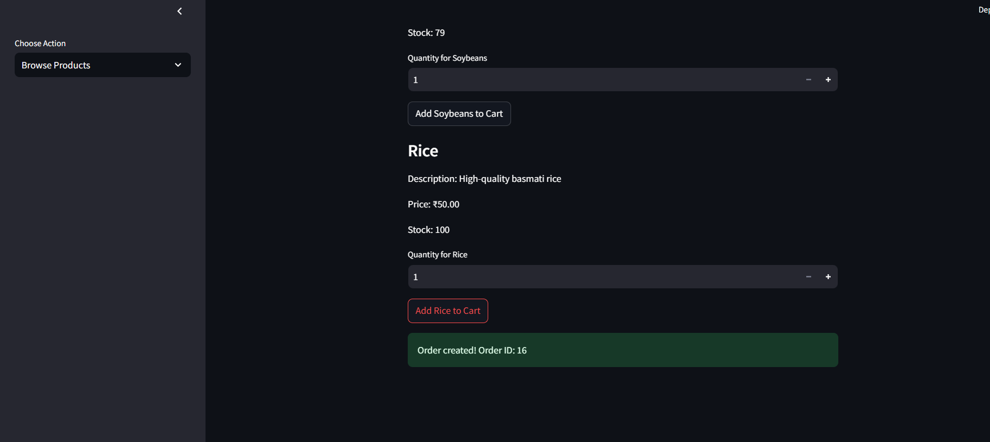

4)My Order(for Buyers)

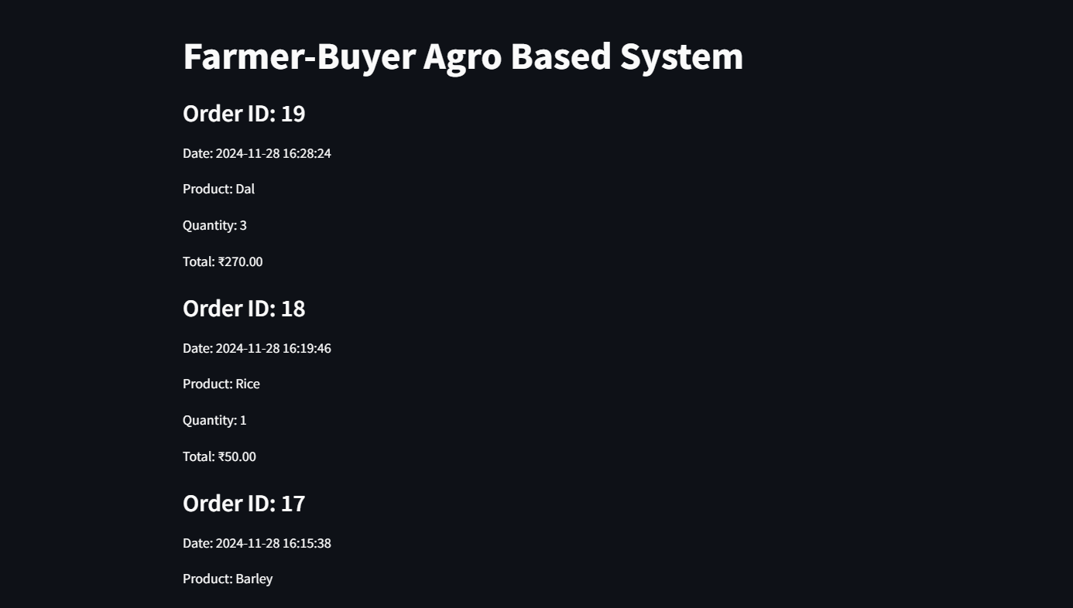

5)Review(for Buyer)

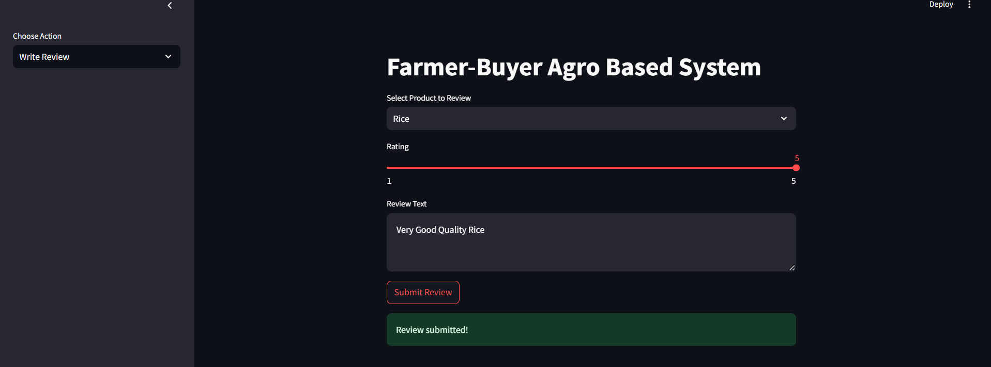

6) View sales

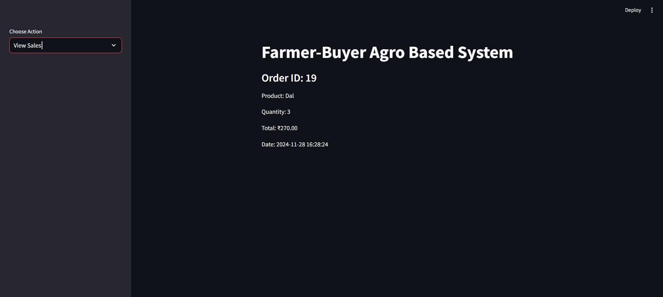

7)Farmer Performance

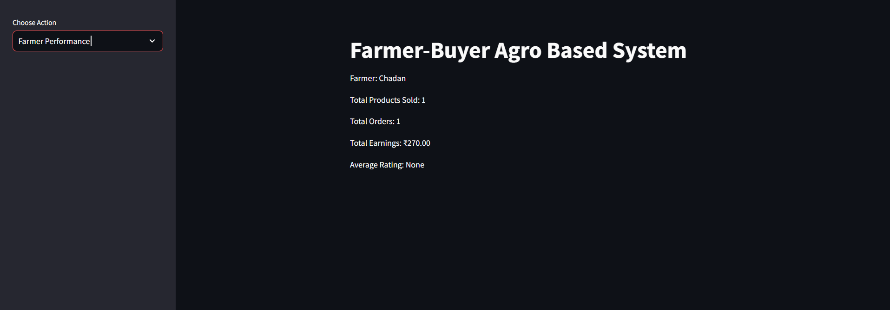

Proecdure and Trigger

1)

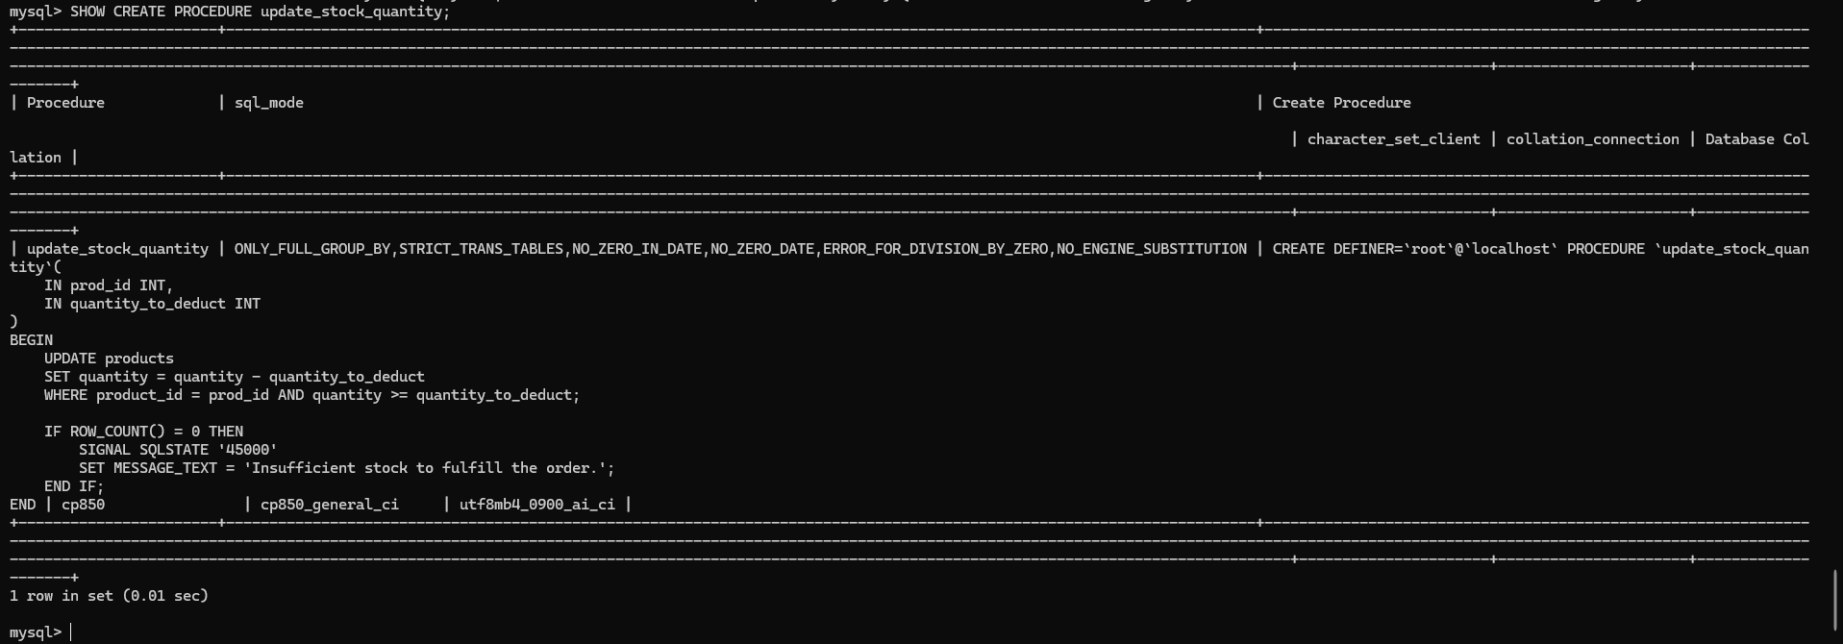

2)

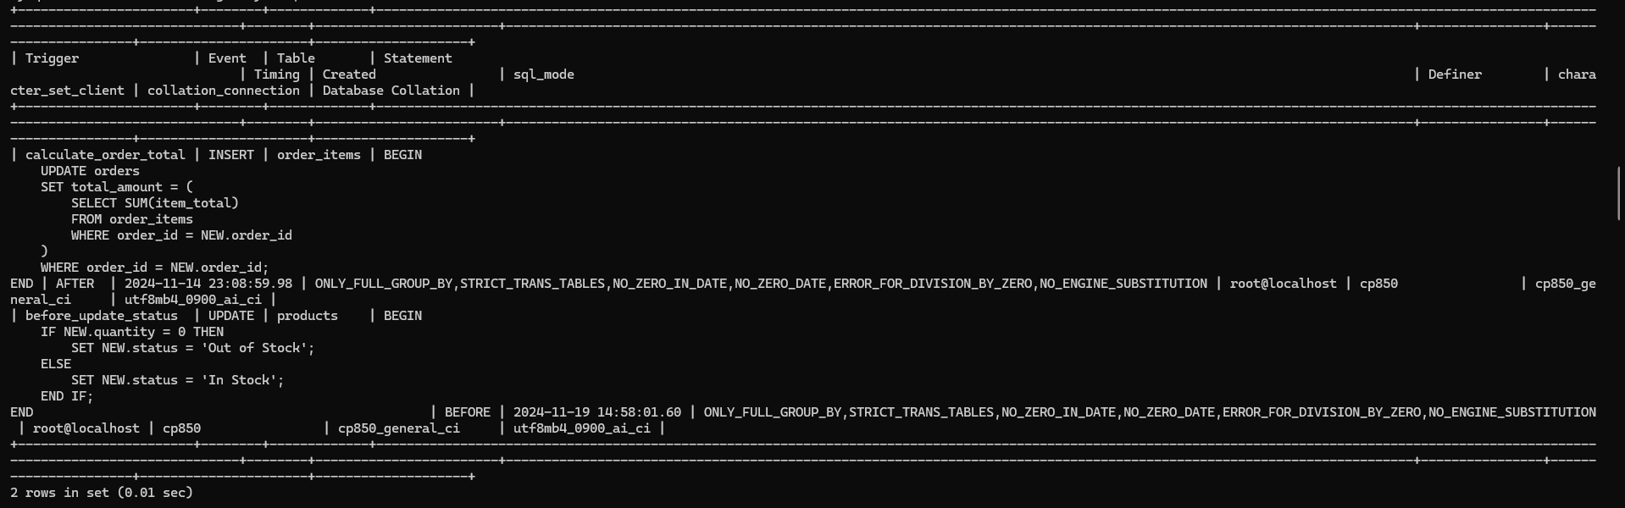

8)Top Products (both For Farmers and Buyers)

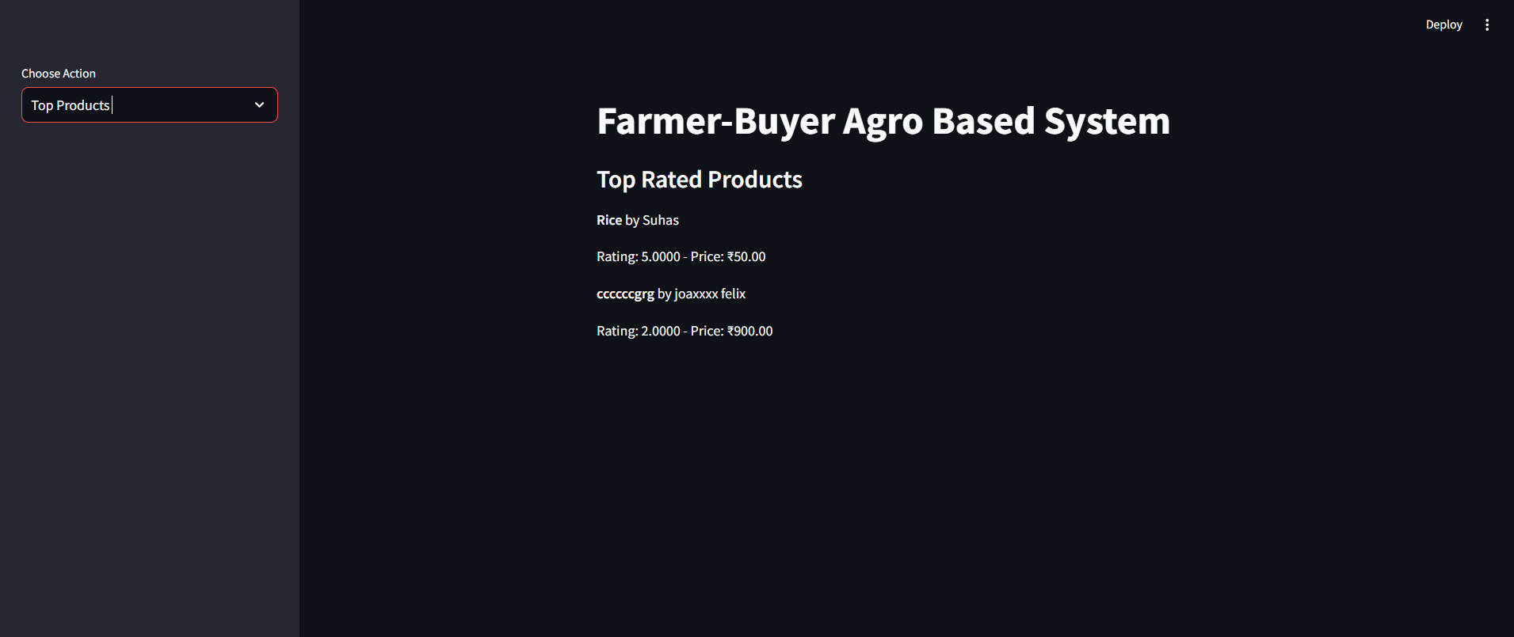

**7. Conclusion**

The **Farmer Agro-Based Management System** is designed to streamline the agricultural sales process by connecting farmers and buyers through an efficient and secure web-based platform. It offers essential features like user registration, product management, order placement, and sales tracking, ensuring ease of use and a seamless experience for both parties. The system's architecture is built on a MySQL database, with strong performance, security, and usability requirements. It is compliant with relevant agricultural regulations and offers a responsive interface across various devices.

The report provides comprehensive documentation of the system's functional and non-functional requirements, ensuring that developers, testers, and stakeholders are aligned in understanding and executing the project. With a focus on reliability, security, and performance, the system aims to enhance the agricultural market by providing an efficient solution for both farmers and buyers.